**THEORY:**

**Java Server Pages (JSP):**

**JSP** technology is used to create web application just like Servlet technology. It can be thought of as an extension to Servlet because it provides more functionality than servlet such as expression language, JSTL, etc.

A JSP page consists of HTML tags and JSP tags. The JSP pages are easier to maintain than Servlet because we can separate designing and development. It provides some additional features such as Expression Language, Custom Tags, etc.

**Advantages of JSP:-**

There are many advantages of JSP over the Servlet. They are as follows :-

1. **Extension to Servlet**: JSP technology is the extension to Servlet technology. We can use all the features of the Servlet in JSP. In addition to, we can use implicit objects, predefined tags, expression language and Custom tags in JSP, that makes JSP development easy.
2. **Easy to maintain**: JSP can be easily managed because we can easily separate our business logic with presentation logic. In Servlet technology, we mix our business logic with the presentation logic.
3. **Fast Development**: No need to recompile and redeploy:- If JSP page is modified, we don't need to recompile and redeploy the project. The Servlet code needs to be updated and recompiled if we have to change the look and feel of the application.
4. **Less code than Servlet:** In JSP, we can use many tags such as action tags, JSTL, custom tags, etc. that reduces the code. Moreover, we can use EL, implicit objects, etc.

**Syntax available in JSP are following:**

1. **Declaration Tag**: It is used to declare variables. Syntax:**-** <%! Dec var %>
2. **Java Scriplets**: It allows us to add any number of JAVA code, variables and expressions.

Syntax:- <% java code %>

1. **JSP Expression**: It evaluates and convert the expression to a string. Syntax:- <%= expression %>
2. **JAVA Comments**: It contains the text that is added for information which has to be ignored.

Syntax: <% -- JSP Comments %>

1. **jsp:useBean action tag**: The jsp:useBean action tag is used to locate or instantiate a bean class. If bean object of the Bean class is already created, it doesn't create the bean depending on the scope. But if object of bean is not created, it instantiates the bean.

**JSP Implicit Objects**

There are **9 jsp implicit objects**. These objects are *created by the web container* that are available to all the jsp pages.

The available implicit objects are out, request, config, session, application etc.

A list of the 9 implicit objects is given below:

|  |  |
| --- | --- |
| **Object** | **Type** |
| out | JspWriter |
| request | HttpServletRequest |
| response | HttpServletResponse |
| config | ServletConfig |
| application | ServletContext |
| session | HttpSession |
| pageContext | PageContext |
| page | Object |
| exception | Throwable |

**GENERAL CODE:**

**SOURCE CODE:**

**meta.jsp:**

<link

href="https://cdn.jsdelivr.net/npm/bootstrap@5.0.2/dist/css/bootstrap.min.css"

rel="stylesheet"

integrity="sha384-EVSTQN3/azprG1Anm3QDgpJLIm9Nao0Yz1ztcQTwFspd3yD65VohhpuuCOmLASjC"

crossorigin="anonymous">

<script

src="https://cdn.jsdelivr.net/npm/bootstrap@5.0.2/dist/js/bootstrap.bundle.min.js"

integrity="sha384-MrcW6ZMFYlzcLA8Nl+NtUVF0sA7MsXsP1UyJoMp4YLEuNSfAP+JcXn/tWtIaxVXM"

crossorigin="anonymous"></script>

<script

src="https://cdn.jsdelivr.net/npm/@popperjs/core@2.9.2/dist/umd/popper.min.js"

integrity="sha384-IQsoLXl5PILFhosVNubq5LC7Qb9DXgDA9i+tQ8Zj3iwWAwPtgFTxbJ8NT4GN1R8p"

crossorigin="anonymous"></script>

<script

src="https://cdn.jsdelivr.net/npm/bootstrap@5.0.2/dist/js/bootstrap.min.js"

integrity="sha384-cVKIPhGWiC2Al4u+LWgxfKTRIcfu0JTxR+EQDz/bgldoEyl4H0zUF0QKbrJ0EcQF"

crossorigin="anonymous"></script>

**header.jsp:**

<%@ page language="java" contentType="text/html; charset=ISO-8859-1"

pageEncoding="ISO-8859-1"%>

<nav class="navbar navbar-expand-lg navbar-light bg-light">

<div class="container-fluid">

<a class="navbar-brand" href="/Prac2/index.jsp">Prac2</a>

<button class="navbar-toggler" type="button" data-bs-toggle="collapse" data-bs-target="#navbarNavDropdown" aria-controls="navbarNavDropdown" aria-expanded="false" aria-label="Toggle navigation">

<span class="navbar-toggler-icon"></span>

</button>

<div class="collapse navbar-collapse" id="navbarNavDropdown">

<ul class="navbar-nav">

<li class="nav-item">

<a class="nav-link active" aria-current="page" href="/Prac2/index.jsp">Q1 Date</a>

</li>

<li class="nav-item">

<a class="nav-link" href="/Prac2/CircleShape.jsp">Q2 Circle Area</a>

</li>

<li class="nav-item">

<a class="nav-link" href="/Prac2/TriangleShape.jsp">Q2 Triangle Area</a>

</li>

<li class="nav-item">

<a class="nav-link" href="/Prac2/Q3.jsp">Q3 </a>

</li>

<li class="nav-item">

<a class="nav-link" href="/Prac2/BugTracker.jsp">Q4 Bug Tracker JDBC</a>

</li>

<li class="nav-item">

<a class="nav-link" href="/Prac2/ViewBugs.jsp">Q4 View Bugs JDBC</a>

</li>

<li class="nav-item">

<a class="nav-link" href="/Prac2/useBeanEg.jsp">Q5 useBean</a>

</li>

<li class="nav-item">

<a class="nav-link" href="/Prac2/CustomTagLib.jsp">Q5 TagLib</a>

</li>

</ul>

</div>

</div>

</nav>

**footer.jsp:**

<footer>

<br/>

<h3>

<center>Created By Narender keswani [MCA-B-24]</center>

</h3>

</footer>

1. **Create a JSP page to display current date and time:**

**SOURCE CODE:**

**index.jsp:**

<%@ page language="java" contentType="text/html; charset=ISO-8859-1"

pageEncoding="ISO-8859-1"%>

<!DOCTYPE html>

<html>

<head>

<meta charset="ISO-8859-1">

<title>Insert title here</title>

<%@ include file="/meta.jsp" %>

</head>

<body>

<jsp:include page="/header.jsp"></jsp:include>

<h2>Create a JSP page to display current date and time</h2>

<br />

<h3>Current Date and Time is :

<% java.util.Date d = new java.util.Date();%>

<%= d.toString() %></h3>

<jsp:include page="/footer.jsp"></jsp:include>

</body>

</html>

**OUTPUT:**

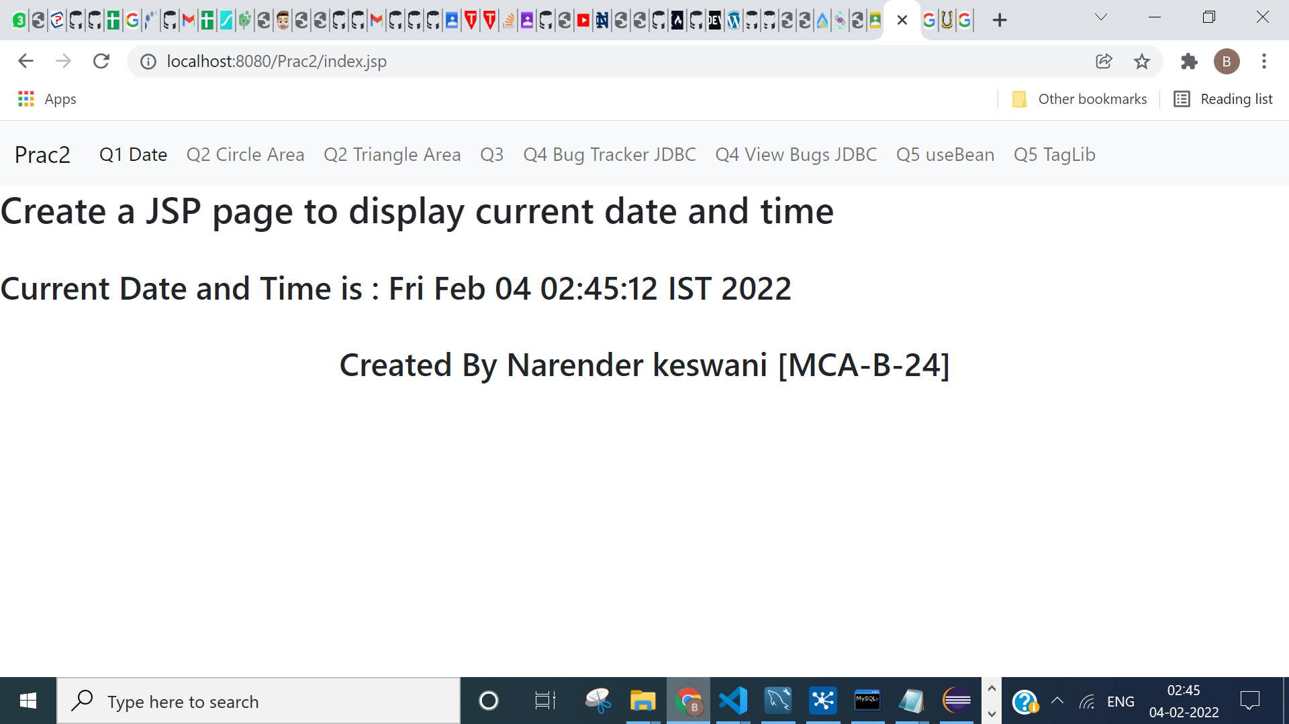

1. **Create a menu driven JSP page that will take input from the user sides and display area of a shape (NOTE: Shape can be triangle or circle input is to taken from user)**

**SOURCE CODE:**

**CIRCLE:**

**CircleShape.jsp:**

<%@ page language="java" contentType="text/html; charset=ISO-8859-1"

pageEncoding="ISO-8859-1"%>

<!DOCTYPE html>

<html>

<head>

<meta charset="ISO-8859-1">

<title>Insert title here</title>

<%@ include file="/meta.jsp"%>

</head>

<body>

<jsp:include page="/header.jsp"></jsp:include>

<div class="container">

<form action="CircleCalc.jsp" method="POST">

<div class="mb-3 row">

<label class="form-label">Radius of Circle</label>

<div class="col-sm-10">

<input type="number" name="c_radius" class="form-control" required />

</div>

</div>

<input type="submit" class="btn btn-primary" value="Find Area">

</form>

</div>

<jsp:include page="/footer.jsp"></jsp:include>

</body>

</html>

**CircleCalc.jsp:**

<%@ page language="java" contentType="text/html; charset=ISO-8859-1"

pageEncoding="ISO-8859-1"%>

<!DOCTYPE html>

<html>

<head>

<meta charset="ISO-8859-1">

<title>Insert title here</title>

<%@ include file="/meta.jsp" %>

</head>

<body>

<%@ include file="/header.jsp" %>

<%

int radius = Integer.parseInt(request.getParameter("c_radius"));

%>

<h3>The Area of Circle is is <%= 3.14 * radius * radius %></h3>

<jsp:include page="/footer.jsp"></jsp:include>

</body>

</html>

**OUTPUT:**

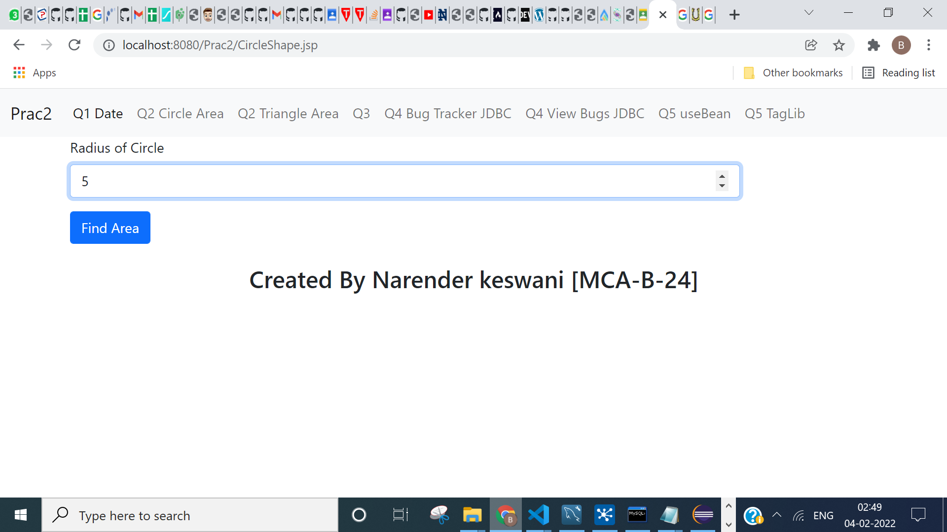

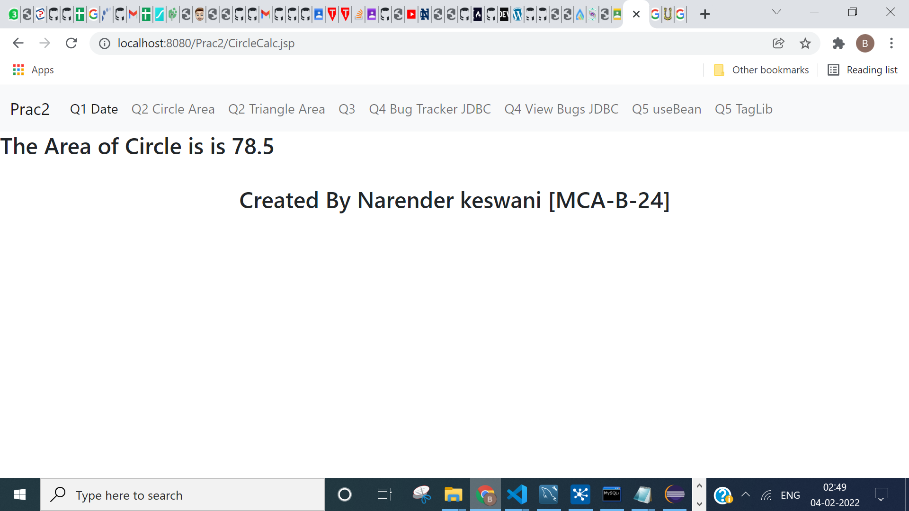

**TRIANGLE:**

**SOURCE CODE:**

**TriangleShape.jsp:**

<%@ page language="java" contentType="text/html; charset=ISO-8859-1"

pageEncoding="ISO-8859-1"%>

<!DOCTYPE html>

<html>

<head>

<meta charset="ISO-8859-1">

<title>Insert title here</title>

<%@ include file="/meta.jsp"%>

</head>

<body>

<jsp:include page="/header.jsp"></jsp:include>

<div class="container">

<form action="TriangleCalc.jsp" method="POST">

<div class="mb-3 row">

<label class="form-label">Base of Triangle</label>

<div class="col-sm-10">

<input type="number" name="b_tri" class="form-control" required />

</div>

</div>

<div class="mb-3 row">

<label class="form-label">Height of Triangle</label>

<div class="col-sm-10">

<input type="number" name="h_tri" class="form-control" required />

</div>

</div>

<input type="submit" class="btn btn-primary" value="Find Area">

</form>

</div>

<jsp:include page="/footer.jsp"></jsp:include>

</body>

</html>

**TriangleCalc.jsp:**

<%@ page language="java" contentType="text/html; charset=ISO-8859-1"

pageEncoding="ISO-8859-1"%>

<!DOCTYPE html>

<html>

<head>

<meta charset="ISO-8859-1">

<title>Insert title here</title>

<%@ include file="/meta.jsp"%>

</head>

<body>

<jsp:include page="/header.jsp"></jsp:include>

<%

int b_tri = Integer.parseInt(request.getParameter("b_tri"));

int h_tri = Integer.parseInt(request.getParameter("h_tri"));

%>

<h3>

The Area of Triangle is

<%= 0.5 * b_tri * h_tri %></h3>

<jsp:include page="/footer.jsp"></jsp:include>

</body>

</html>

**OUTPUT:**

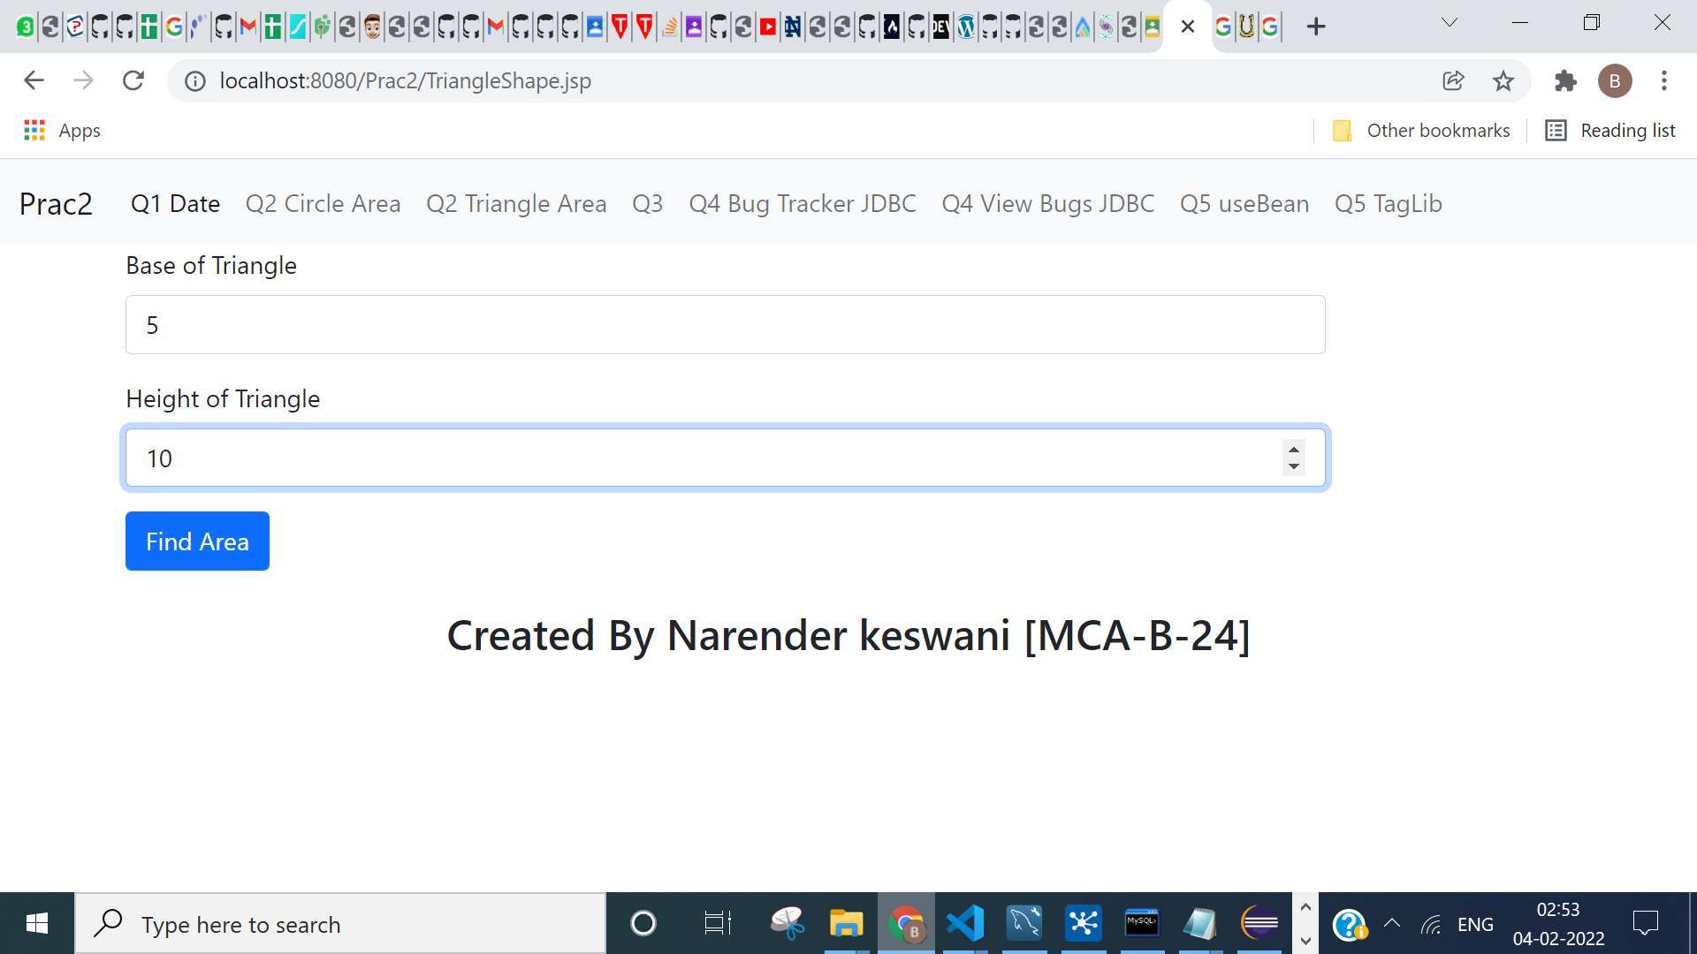

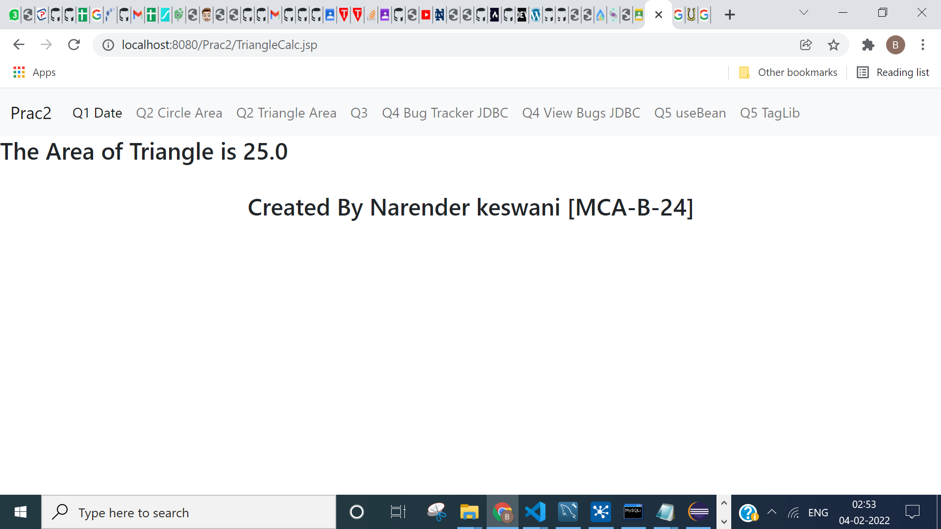

1. **Create JSP page to demonstrate the use of scriplet, expression and declaration tag.**

**SOURCE CODE:**

**Q3.jsp:**

<%@ page language="java" contentType="text/html; charset=ISO-8859-1"

pageEncoding="ISO-8859-1"%>

<!DOCTYPE html>

<html>

<head>

<meta charset="ISO-8859-1">

<title>Insert title here</title>

<%@ include file="/meta.jsp" %>

</head>

<body>

<jsp:include page="/header.jsp"></jsp:include>

<div class="container">

<h2>Create JSP page to demonstrate the use of

scriplet, expression and declaration tag</h2>

<h5>SOURCE CODE:</h5>

<pre>

Delaration Tag:

< %! int a = 10; % >

< %! int b = 10; % >

Scriplet Tag:

< % int t = a+b; % >

Expression:

< % = t % > </pre>

<h5>OUTPUT:

<%! int a = 10; %>

<%! int b = 10; %>

<% int t = a+b; %>

<%= t %>

</h5>

</div>

<jsp:include page="/footer.jsp"></jsp:include>

</body>

</html>

**OUTPUT:**

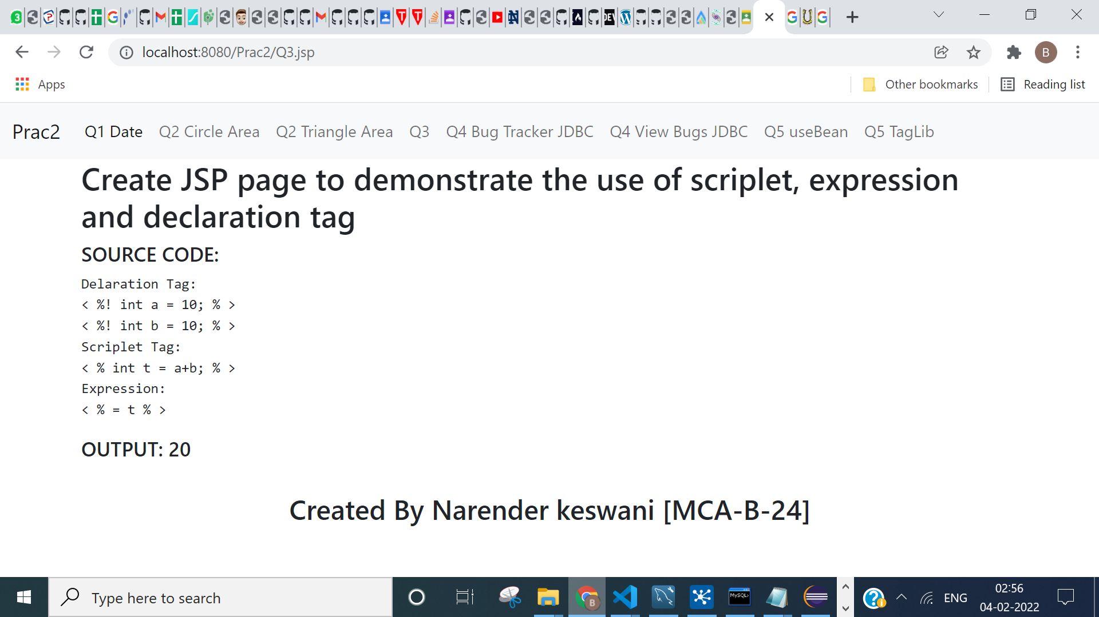

1. **Create a JSP of registration form an store the same in database OR Create a JSP page to demonstrate the use of  config,  request, response, out and session directive**

**SOURCE CODE:**

**BugTracker.jsp:**

<%@ page language="java" contentType="text/html; charset=ISO-8859-1"

pageEncoding="ISO-8859-1"%>

<!DOCTYPE html>

<html>

<head>

<meta charset="ISO-8859-1">

<title>Insert title here</title>

<%@ include file="/meta.jsp"%>

</head>

<body>

<jsp:include page="/header.jsp"></jsp:include>

<div class="container">

<h1 class="display-1">BUG TRACKER</h1>

<form action="InsertBug.jsp" method="POST">

<div class="mb-3 row">

<label class="form-label">Name of Bug</label>

<div class="col-sm-10">

<input type="text" name="b_name" class="form-control"

placeholder="Name of Bug" required />

</div>

</div>

<div class="mb-3 row">

<label class="form-label">Bug Date</label>

<div class="col-sm-10">

<input type="date" name="b_date" class="form-control" required />

</div>

</div>

<div class="mb-3 row">

<label class="form-label">Bug Priority</label>

<div class="col-sm-10">

<select name="b_priority" class="form-control" required>

<option value="LOW">LOW</option>

<option value="MEDIUM">MEDIUM</option>

<option value="HIGH">HIGH</option>

</select>

</div>

</div>

<div class="mb-3 row">

<label class="form-label">Bug Description</label>

<div class="col-sm-10">

<textarea name="b_desc" class="form-control" rows="10" cols="30"

placeholder="Enter the Bug Description" required></textarea>

</div>

</div>

<input type="submit" class="btn btn-primary" value="Add">

</form>

</div>

<jsp:include page="/footer.jsp"></jsp:include>

</body>

</html>

**InsertBug.jsp:**

<%@ page language="java" contentType="text/html; charset=ISO-8859-1"

pageEncoding="ISO-8859-1"%>

<%@page import="java.sql.*,java.util.*"%>

<!DOCTYPE html>

<html>

<head>

<meta charset="ISO-8859-1">

<title>Insert title here</title>

<%@ include file="/meta.jsp"%>

</head>

<body>

<jsp:include page="/header.jsp"></jsp:include>

<%

String bug_name = request.getParameter("b_name");

String bug_date = request.getParameter("b_date");

String bug_priority = request.getParameter("b_priority");

String bug_desc = request.getParameter("b_desc");

try

{

Class.forName("com.mysql.jdbc.Driver");

Connection conn = DriverManager.getConnection("jdbc:mysql://localhost:3308/bug_tracker", "root", "Narend-10");

PreparedStatement pst = null;

String Query = "INSERT INTO bugs (b_name, b_date, b_priority, b_desc) values (?, ?, ?, ?)";

pst = conn.prepareStatement(Query);

pst.setString(1, bug_name);

pst.setString(2, bug_date);

pst.setString(3, bug_priority);

pst.setString(4, bug_desc);

pst.executeUpdate();

%>

<h3>Data is successfully inserted!</h3>

<%

}

catch(Exception e)

{

System.out.print(e);

e.printStackTrace();

%>

<h3>Some Error was occurred!</h3>

<%

}

%>

<jsp:include page="/footer.jsp"></jsp:include>

</body>

</html>

**OUTPUT:**

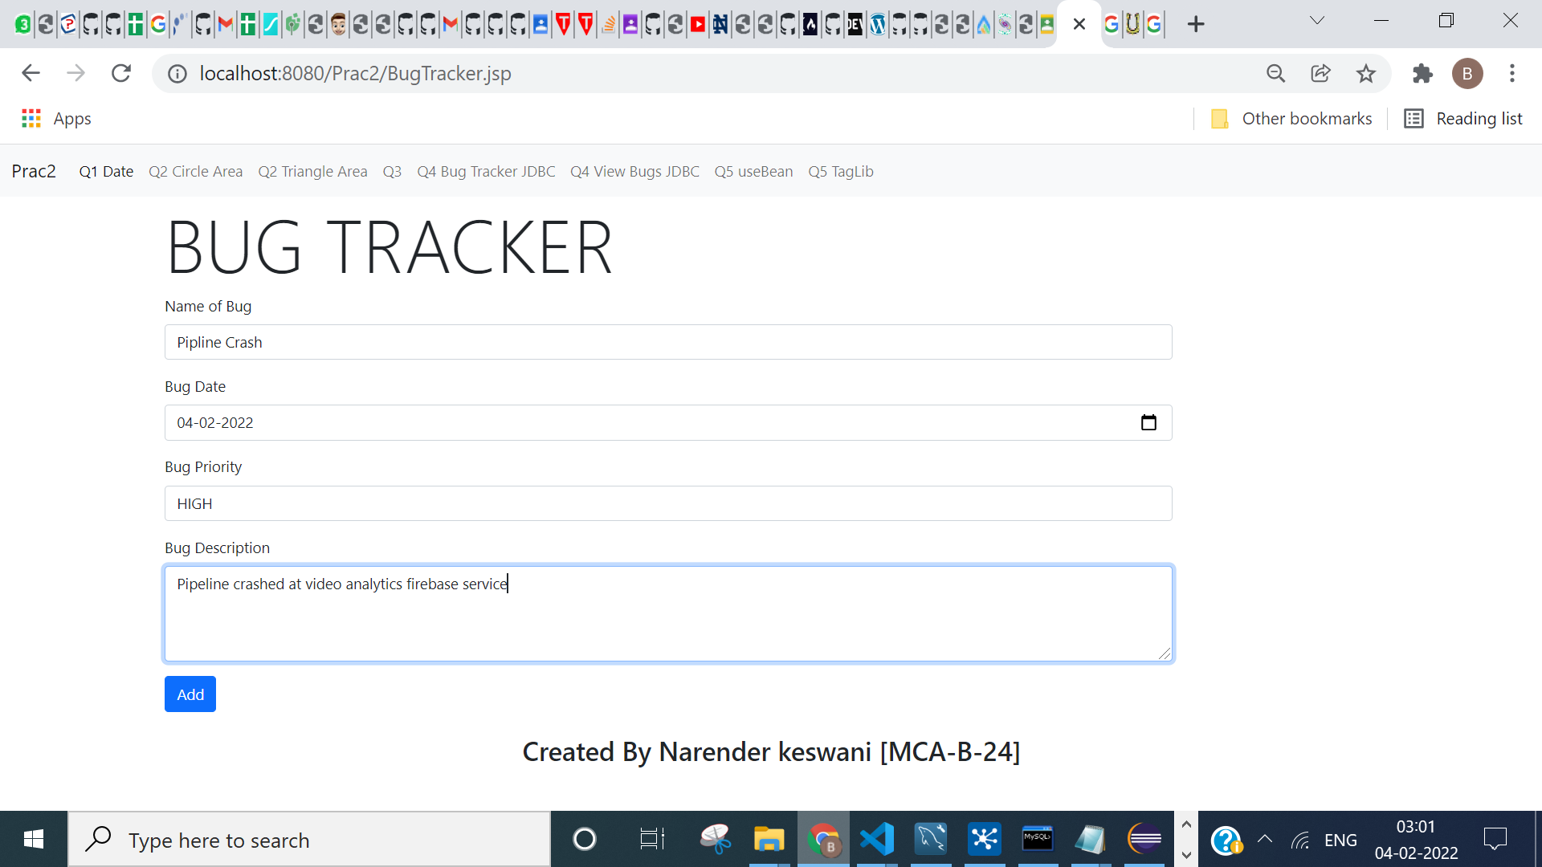

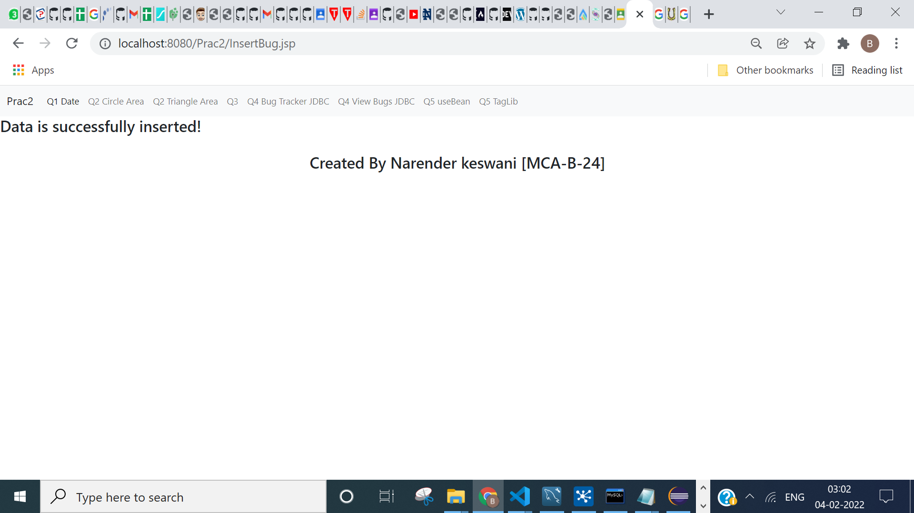

**ViewBugs.jsp:**

<%@ page language="java" contentType="text/html; charset=ISO-8859-1"

pageEncoding="ISO-8859-1"%>

<%@page import="java.sql.*,java.util.*"%>

<!DOCTYPE html>

<html>

<head>

<meta charset="ISO-8859-1">

<title>Insert title here</title>

<%@ include file="/meta.jsp"%>

</head>

<body>

<jsp:include page="/header.jsp"></jsp:include>

<h3>Bugs List</h3>

<table class="table">

<thead>

<tr>

<th scope="col">ID</th>

<th scope="col">NAME</th>

<th scope="col">DATE</th>

<th scope="col">PRIORITY</th>

<th scope="col">DESCRIPTION</th>

</tr>

</thead>

<tbody>

<%

try {

Class.forName("com.mysql.jdbc.Driver");

Connection conn = DriverManager.getConnection("jdbc:mysql://localhost:3308/bug_tracker", "root", "Narend-10");

Statement statement = conn.createStatement();

String sql = "select * from bugs";

ResultSet resultSet = statement.executeQuery(sql);

while (resultSet.next()) {

%>

<tr>

<td><%=resultSet.getInt("b_id")%></td>

<td><%=resultSet.getString("b_name")%></td>

<td><%=resultSet.getString("b_date")%></td>

<td><%=resultSet.getString("b_priority")%></td>

<td><%=resultSet.getString("b_desc")%></td>

</tr>

<%

}

conn.close();

} catch (Exception e) {

e.printStackTrace();

%>

<h3>Some Error was occurred!</h3>

<%

}

%>

</tbody>

</table>

<jsp:include page="/footer.jsp"></jsp:include>

</body>

</html>

**OUTPUT:**

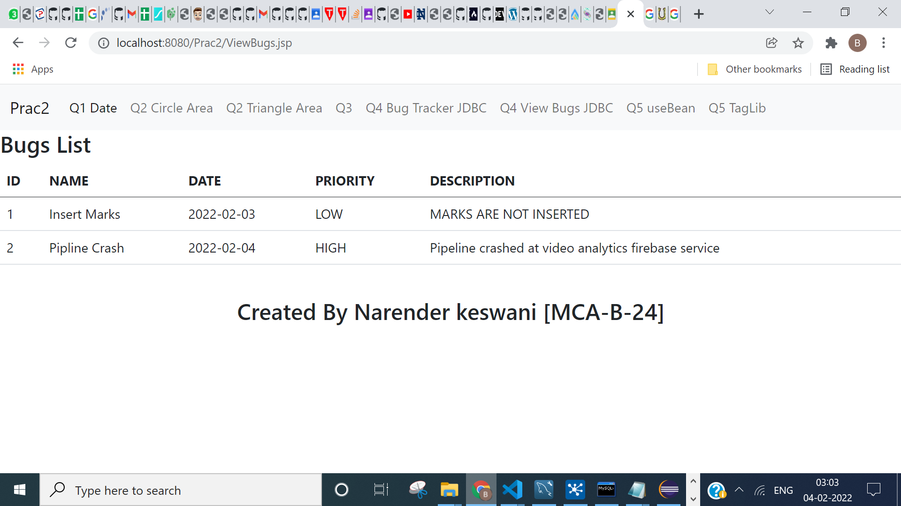

1. **Create a JSP page to UseBean tag and taglib Tag in JSP.**

**SOURCE CODE:**

**CalcBean.java:**

package beans;

public class CalcBean {

public int cube(int n){return n*n*n;}

}

**useBeanEg.jsp:**

<%@ page language="java" contentType="text/html; charset=ISO-8859-1"

pageEncoding="ISO-8859-1"%>

<!DOCTYPE html>

<html>

<head>

<meta charset="ISO-8859-1">

<title>Insert title here</title>

<%@ include file="/meta.jsp" %>

</head>

<body>

<jsp:include page="/header.jsp"></jsp:include>

<jsp:useBean id="obj" class="beans.CalcBean"/>

<%

int m=obj.cube(3);

%>

<h5>Cube of 3 is: <%= m %></h5>

<jsp:include page="/footer.jsp"></jsp:include>

</body>

</html>

**OUTPUT:**

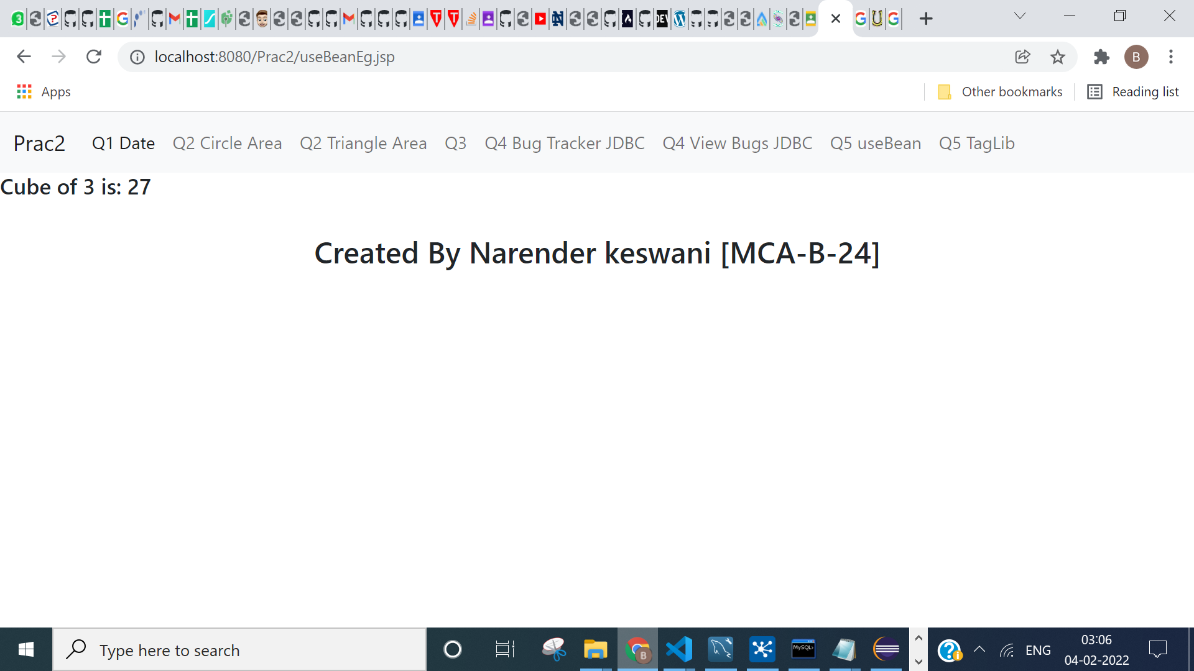

1. **EXAMPLE OF CUSTOM TAG LIB DIRECTIVE:**

**SOURCE CODE:**

**MyTagHandler:**

package TagHandlers;

/**

*

* @author NARENDER KESWANI

*/

import java.io.IOException;

import java.util.Calendar;

import javax.servlet.jsp.JspException;

import javax.servlet.jsp.JspWriter;

import javax.servlet.jsp.tagext.TagSupport;

public class MyTagHandler extends TagSupport{

@Override

public int doStartTag() throws JspException {

JspWriter out=pageContext.getOut();//returns the instance of JspWriter

try{

out.print(Calendar.getInstance().getTime());//printing date and time using JspWriter

}catch(IOException e){System.out.println(e);}

return SKIP_BODY;//will not evaluate the body content of the tag

}

}

**Mytag.tld:**

<?xml version="1.0" encoding="UTF-8"?>

<taglib version="2.1" xmlns="http://java.sun.com/xml/ns/javaee" xmlns:xsi="http://www.w3.org/2001/XMLSchema-instance" xsi:schemaLocation="http://java.sun.com/xml/ns/javaee http://java.sun.com/xml/ns/javaee/web-jsptaglibrary_2_1.xsd">

<tlib-version>1.0</tlib-version>

<short-name>mytag</short-name>

<uri>/WEB-INF/tlds/mytag</uri>

<tlib-version>1.0</tlib-version>

<jsp-version>2.0</jsp-version>

<short-name>My Custom Tag</short-name>

<tag>

<name>today</name>

<tag-class>TagHandlers.MyTagHandler</tag-class>

<body-content>empty</body-content>

</tag>

</taglib>

**JSP:**

<%--

Document : index

Created on : 4 Feb, 2022, 8:54:42 PM

Author : NARENDER KESWANI

--%>

<%@ taglib uri="WEB-INF/tlds/mytag.tld" prefix="m" %>

Current Date and Time is: <m:today/>

</body>

</html>

**OUTPUT:**

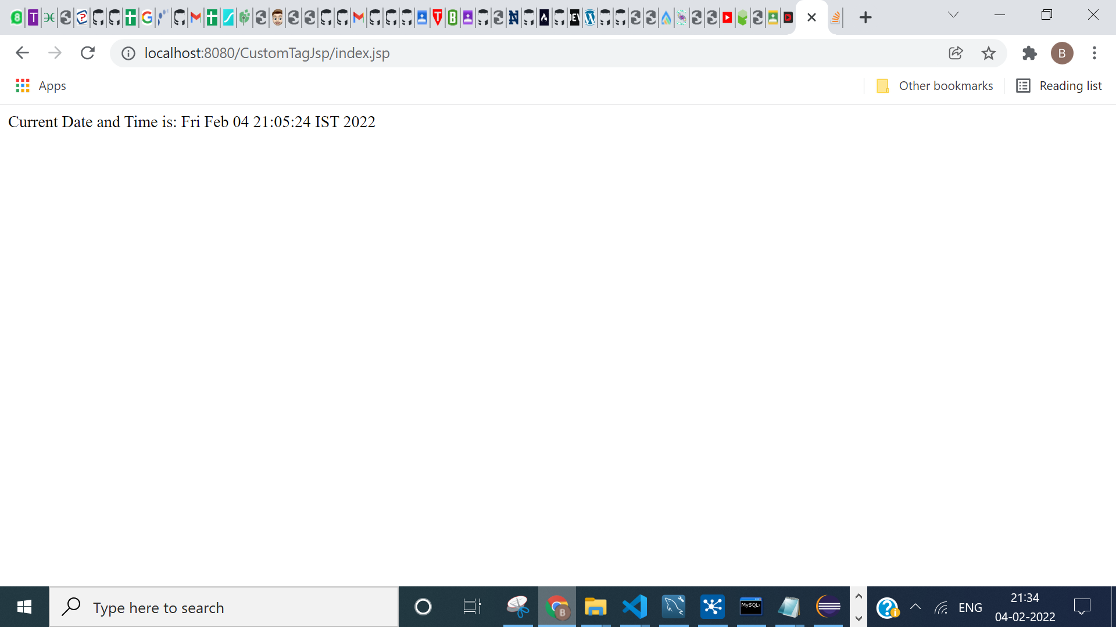

**CONCLUSION:**

I have learned about JSP, scriplets, declaration, expression, jdbc, useBean, custom tags, etc